**ASSIGNMENT 1**

**Submitted by:**

**Lavanya Lavanya**

**Student ID: 22077323**

**Submitted to:**

**Professor: Nawaz Chowdhury**

**Subject: Programming Concepts II**

**Course code: CSD113**

Honesty Statement: “I declare that this submission is my work in compliance with Sault College Academic Policies.”

**Due date: 15 February 2024**

Contents

Lab Instructions 5

Step 1: 5

Step 2: 6

Step 3: 6

Step 4: 7

Step 5: 8

Step 6: 9

References: 10

Figure 1:Basic Structure of Lab Created 5

Figure 2:Created Table View In Scene Builder 6

Figure 3:Created database and Inserted some data in it 7

Figure 4:Created a Modal Class For Employee Table 8

Figure 5:Controller Class created with reference to Employee Modal 8

Figure 6:Created Connection with Database 9

# **Lab Instructions**

## Step 1:

Started IntelliJ Idea and created a basic javaFx project.

.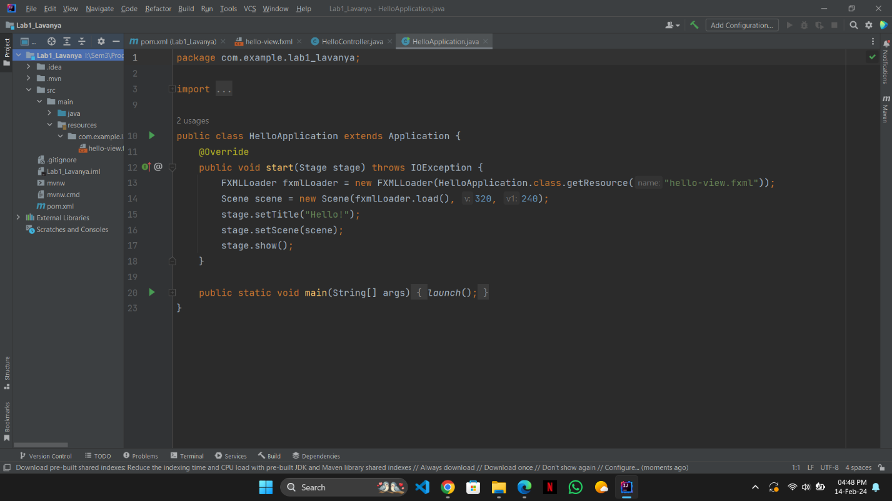

Figure 1:Basic Structure of Lab Created

## Step 2:

After Creating the Basic Template started working in scene builder to create a button and a table view.

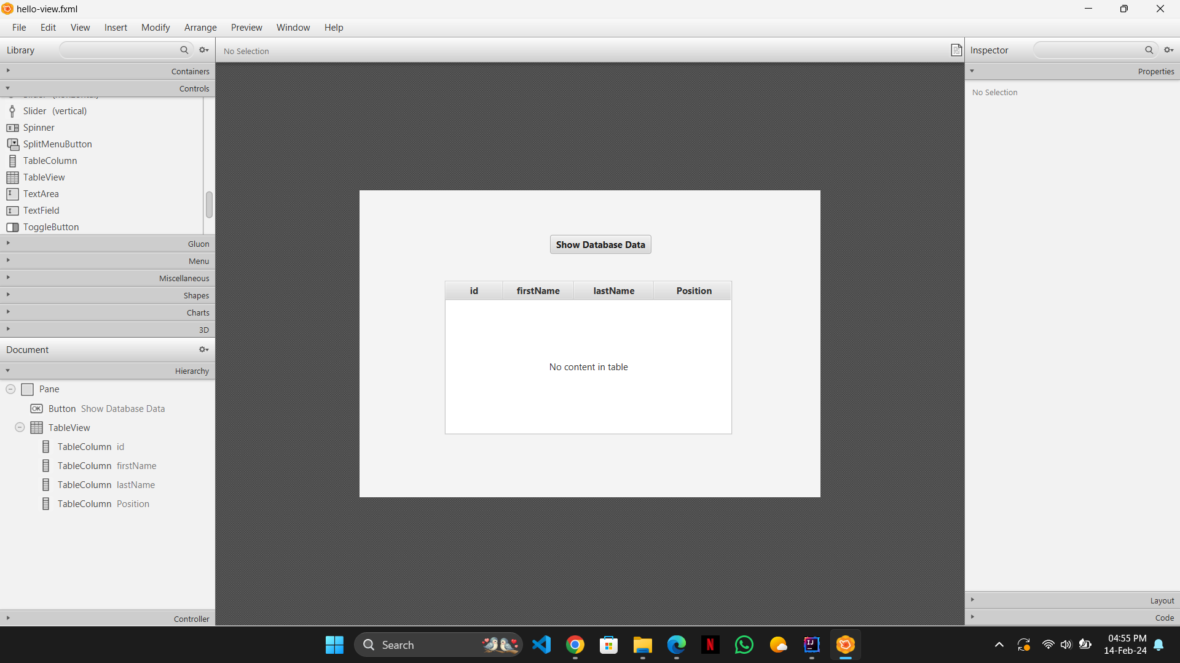

Figure 2:Created Table View In Scene Builder

## Step 3:

Created a SQL database named employeeFXLab1 and entered data of several employees in it to show in the table view.

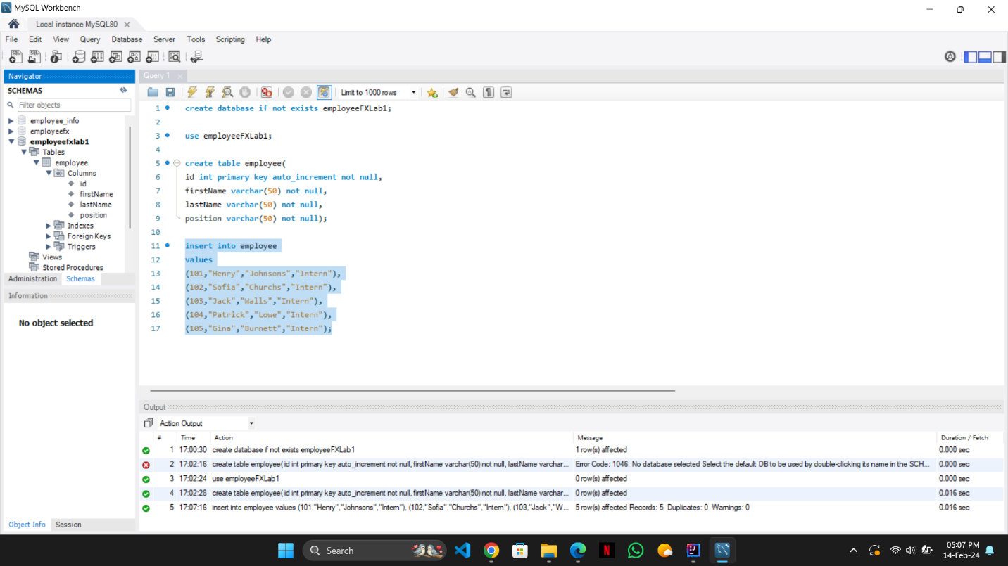

Figure 3:Created database and Inserted some data in it

## Step 4:

Created Model Employee with a constructor, getters and setter with same fields as created in the SQL database.

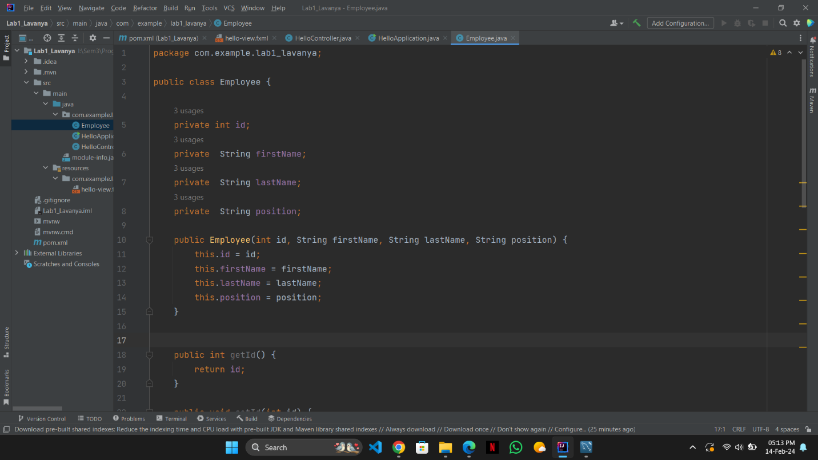

Figure 4:Created a Modal Class For Employee Table

## Step 5:

Created a controller class with all the necessary elements of **hello-view.fxml** file.

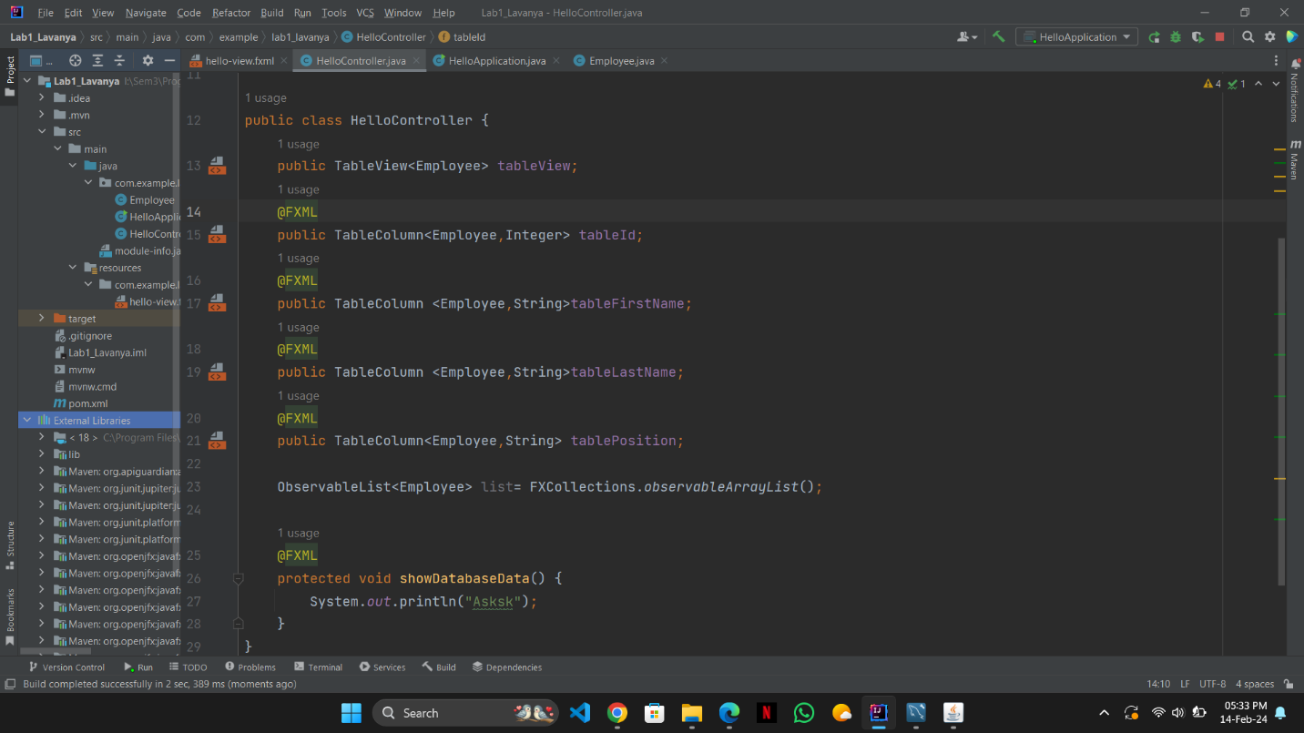

Figure 5:Controller Class created with reference to Employee Modal

## Step 6:

Wrote code to create connection with database giving url,password and username writing a query i.e.

SELECT * FROM employee;

To get all the employee data from employee table in form of a result set.

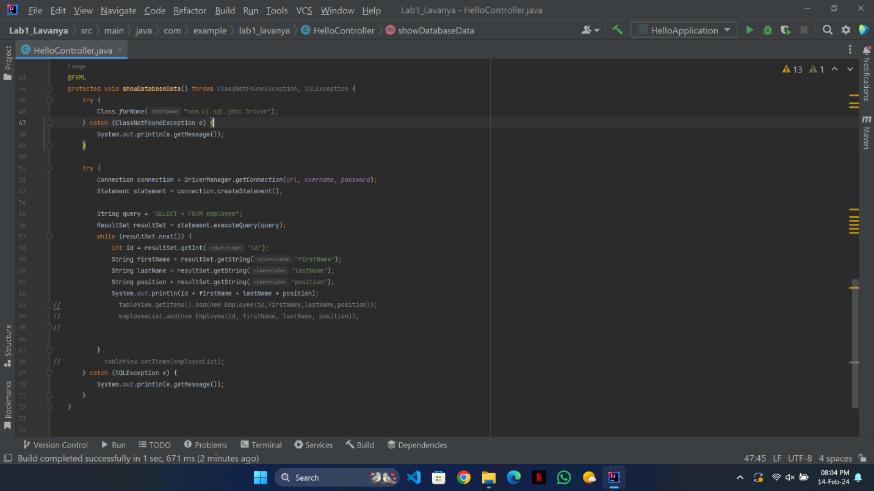

Figure 6:Created Connection with Database

# References:

1. Jenkov, Jakob. “JavaFX TableView.” *Jenkov.com*, jenkov.com/tutorials/javafx/tableview.html.